REGULAR MEETING
VILLAGE OF MORRILL BOARD OF TRUSTEES
October 7, 2025

A Regular Meeting of the Chairman and Board of Trustees of the Village of Morrill, Nebraska was held on October 7, 2025, immediately following the Public Hearings for the 1-&-6 Year Plan at the Village of Morrill Legion Hall. Notice about the meeting had been published according to law, in the Star Herald, a newspaper published of general circulation in the Village and posted in 3 conspicuous places within the Village of Morrill. The notice stated the date, hour and place of the meeting, that the meeting would be open to the public, that anyone with a disability desiring reasonable accommodation to attend the meeting should contact the Village office, and that an agenda of the meeting kept continuously current was available for public inspection at the office of the Village; provided, however, the Village Board could modify the agenda at the meeting if it determined that an emergency so required. An agenda kept continuously current was always available for public inspection at the Village office from the date of publication of the notice to the time of the meeting. A similar notice, together with a copy of the agenda, was also delivered to each Board Member.

Chairman Hart presided and Clerk Schmidt recorded the proceedings. Hart directed the public a copy of the Nebraska Open Meetings Act, posted on the north wall for the public’s review. The following Board Members were present: Neal Hart, Steve Engleman, David Purviance, Joe Conrad and Kim Schledewitz. Also in attendance was Libby Stobel from Simmons Olsen Law Firm.

Moved by Member Hart and seconded by Member Purviance to approve the agenda with notation that Item 13 discussion on Tree on Scott Street would not be discussed.
YEAS: Hart, Conrad, Engleman, Purviance, and Schledewitz NAYS: None, ABSENT: None.

Moved by Member Conrad and seconded by Member Engleman that the minutes from September 9, 2025, Public Hearing and the Regular Meeting and September 15, 2025, Board of Adjustment meeting be approved. YEAS: Hart, Conrad, Engleman, Purviance, and Schledewitz NAYS: None, ABSENT: None.

Moved by Member Engleman and seconded by Member Schledewitz to approve September 30, 2025, Treasurer’s Report. YEAS: Hart, Conrad, Engleman, Purviance, and Schledewitz NAYS: None, ABSENT: None.

Chairman Hart asked if any citizens with business not scheduled on the agenda wished to include an item providing the Village Board determines the item requires emergency action. There were no emergency items.

Moved by Member Hart and seconded by Member Schledewitz to approve Adopt Resolution 25-10 approving the 1-&-6 Year Plan. YEAS: Hart, Conrad, Engleman, Purviance, and Schledewitz NAYS: None, ABSENT: None.

Moved by Member Schledewitz and seconded by Member Purviance to approve the KENO fund request for Morrill School Backpack Program in the amount of $3,000.00. YEAS: Hart, Conrad, Engleman, Purviance, and Schledewitz NAYS: None, ABSENT: None.

Next on the agenda was discussion regarding a KENO request for help with rent for the Morrill Farmers Market for wintertime rent of the Legion. The KENO request does not meet Nebraska Statutory Requirement for use of KENO funds, so no action was taken.

Moved by Member Hart and seconded by Member Conrad to approve Michelle Hill to be a member of the Morrill Volunteer Fire Department. YEAS: Hart, Conrad, Engleman, Purviance, and Schledewitz NAYS: None, ABSENT: None.

Moved by Member Purviance and seconded by Member Schledewitz to approve the change of the November meeting date from November 11th, a holiday, to November 12th at 6:00 p.m. YEAS: Hart, Conrad, Engleman, Purviance, and Schledewitz NAYS: None, ABSENT: None.

Moved by Member Conrado and seconded by Member Engleman to Ratify the signatures to the NDOT Mitchell to Morrill Project Exception for Temporary Occupancy Project for ADA Ramps at Steen Park which was signed prior to the meeting. YEAS: Hart, Conrad, Engleman, Purviance, and Schledewitz NAYS: None, ABSENT: None.

Next on the agenda was Discussion Regarding Adopting Resolution 25-11 regarding Drug Testing for all Employees and a Zero Tolerance Policy for Positive Drug Test Results. Moved by Member Conrad and seconded by Member Hart to Adopt Resolution 25-11, setting a policy for all employees to be entered into a random pool and using Option #2 for the positive test results policy. YEAS: Hart, Conrad, Engleman NAYS: Purviance, Schledewitz ABSENT: None.

An opportunity for public comment was provided. Public comments were as follows: Pete Cawiezel shared the Christmas Stroll will be held on December 1st this year from 6:00 to 8:00 p.m. Santa confirmed he will be in attendance. Pete also introduced Dylan Cecil as the New Library Director and shared that he and his assistant are doing a wonderful job. Erica Curry shared that there will be a tree planting event tomorrow at 4:00 p.m. at FoMo Park for those who would like to help. Morrill was awarded 17 trees through the Trees for Nebraska Towns.

The Village Board then received written reports from departments.

The next item on the agenda was the approval of bills and expenses. It was moved by Member Conrad and seconded by Member Hart to approve all claims as presented.

Village of Morrill Ref 200.00, 200.00, 200.00, 200.00, 200.00, 200.00, 200.00
Payroll 31530.46, 31989.98
941 Taxes 8029.41, 8307.28
Credit Card Fees 39.10, 25.90, 206.93
State Farm Life Ins 297.00
Edward Jones Retirement 4286.00
Nebraska Department of Revenue Tax 2280.95, 18395.96, 84.28
Village of Morrill Util 1900.81
MES Don 2000.00
Visa Uniform, Hotel, Food 859.79, 52.53, 911.00
Danko Sup 1010.00
USave Fuel 74.75

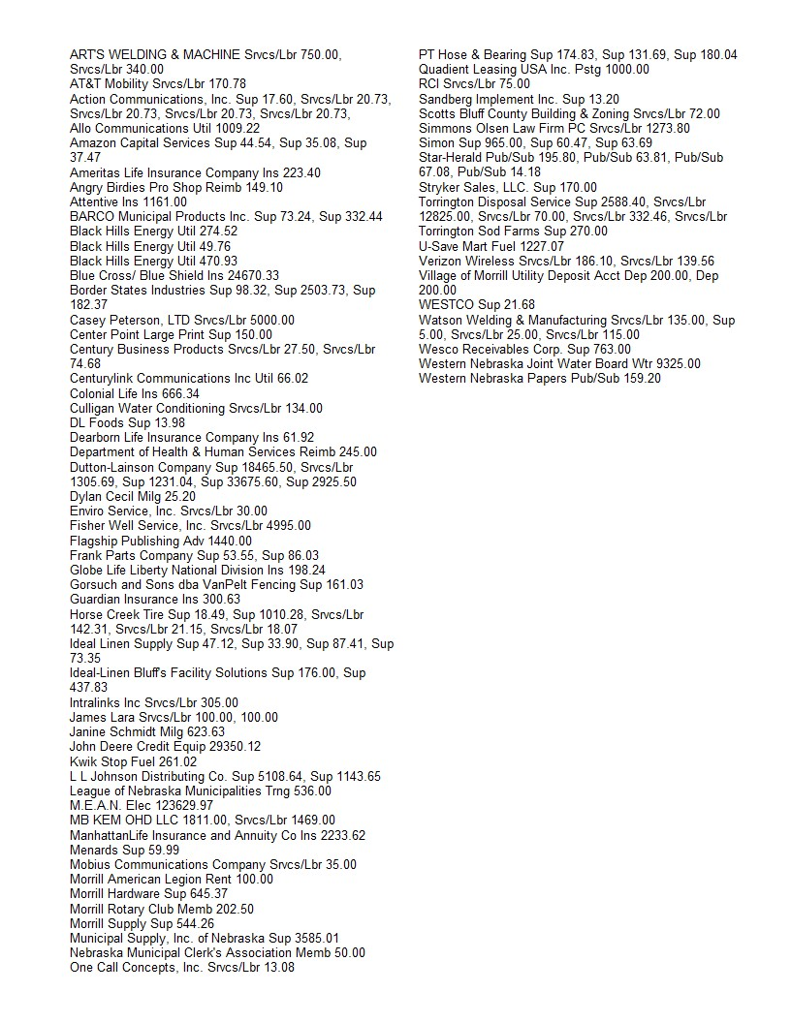
The next Regular Board of Trustee Meeting will be held on November 12, 2025, at 6:00 P.M.

The last item on the agenda was a motion to adjourn by Member Schledewitz and seconded by Member Purviance. YEAS: Hart, Conrad, Engleman, Purviance, and Schledewitz NAYS: None, ABSENT: None.
.
The meeting was then adjourned at 7:20 p.m.

/s/ Janine K. Schmidt /s/ Neal Hart
Janine K. Schmidt Neal Hart
CMC/Treasurer Chairman, Board of Trustees

